HUE MONUMENTS, VIET NAM

3D2N

OVERVIEW

## location

Located on the bank of Song Huong- Perfume River; Hue, the capital of Thua Thien Hue province in Central Vietnam, is 700 km southern Hanoi, 1100km northern Ho Chi Minh City, and only a few miles from the sea. Not until 1945 was Hue the national capital, the political, cultural and religious center of Vietnam under the control of Nguyen Dynasty. Most well-known for its historic values; Hue had been recognized as one of the World Heritage Sites by UNESCO.

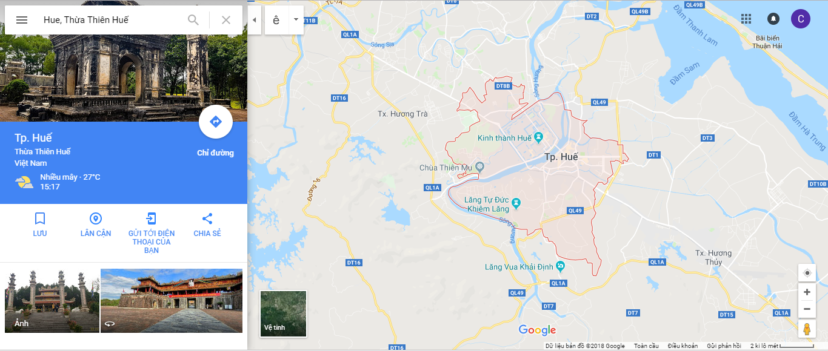

## Characteristics

The center of Vietnam, Huế was the capital city of Vietnam for approximately 150 years during feudal times (1802–1945), and the royal lifestyle and customs have had a significant impact on the characteristics of the people of Huế. That impact can still be felt.

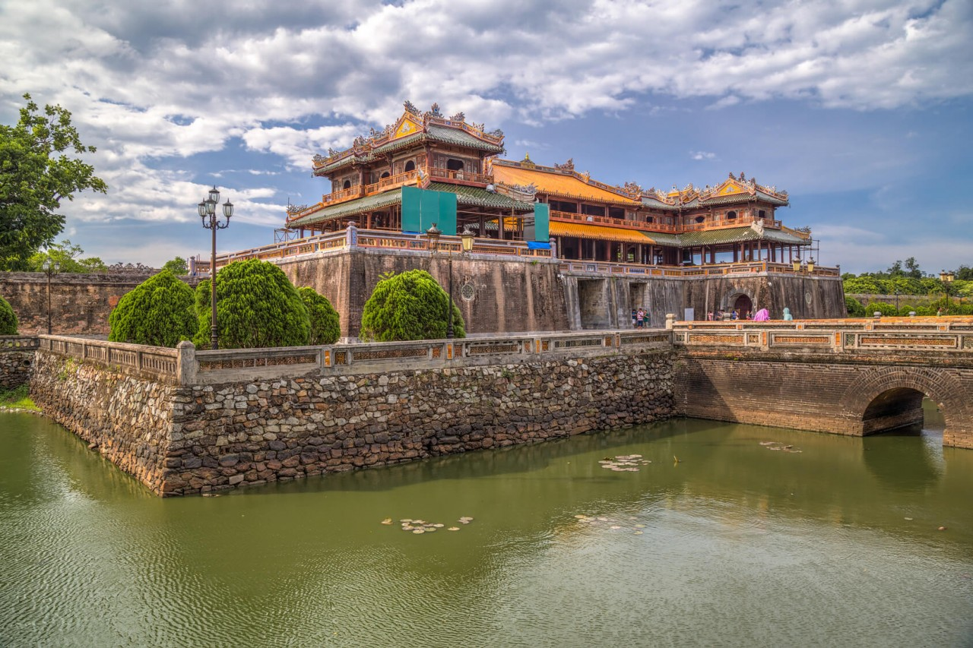

|  |  |
| --- | --- |
|  | SAI GON TO HUE |

## how to get to HUE

* By plane:

From Tan Son Nhat International Aiport in Saigon to Hue is with Phu Bai International Airport

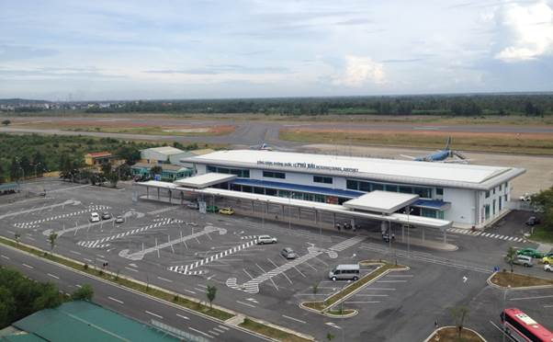

* **Royal Tombs**

Another great way to get a taste of the culture is by visiting a few of the tombs surrounding Hue, Vietnam. While there are seven to choose from, popular tombs are the tombs of Minh Mang, Tu Duc, Khai Dinh, and Dong Khanh.

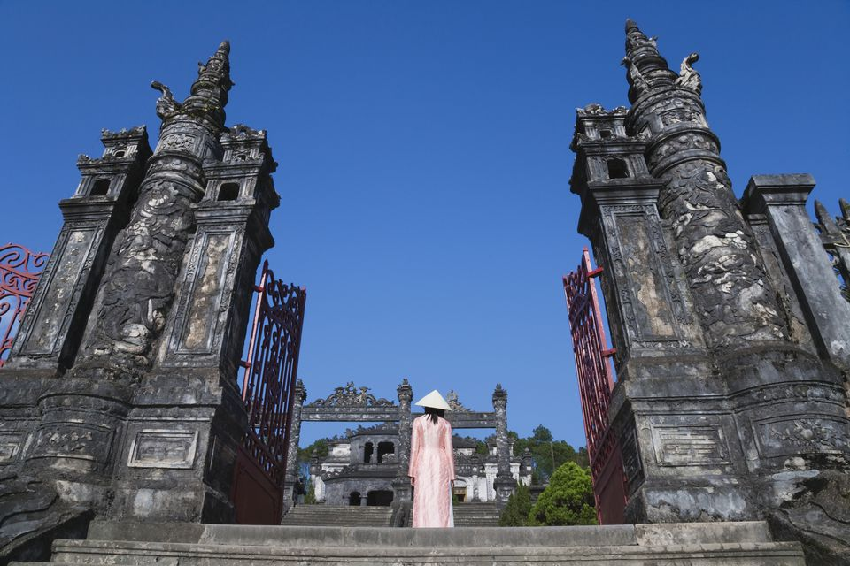

Tu Duc's tomb, located 5km south of Hue, has expansive grounds, so if you want to see it all then be prepared to set plenty of time aside. Although, you won't be seeing the tomb where Tu Duc was laid to rest, as he was buried in a secret location somewhere in Hue

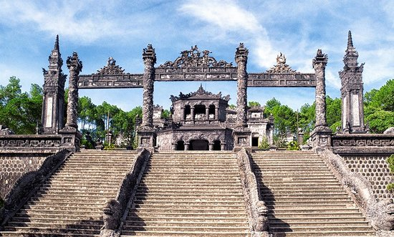

The tomb of Khai Dinh is different from what you might expect, especially if you visit it after checking out Hue's other tombs. It has a mixture of Vietnamese and European architecture, due to the Emperor Khai Dinh's close association with France.

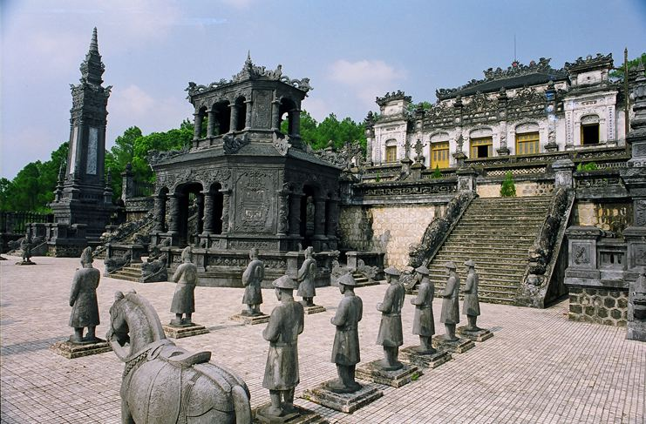

**18:00 PM:** check in hotel to have dinner and relax.

|  |  |
| --- | --- |
|  |  |

|  |  |
| --- | --- |
|  | HANOI CAPITAL |

* **Hue Imperial Citadel**

Famously being one of Vietnam’s seven UNESCO World Heritage Sites, the Imperial City of Hue has long been a must-see attraction for tourists visiting a hidden charm of Vietnam.

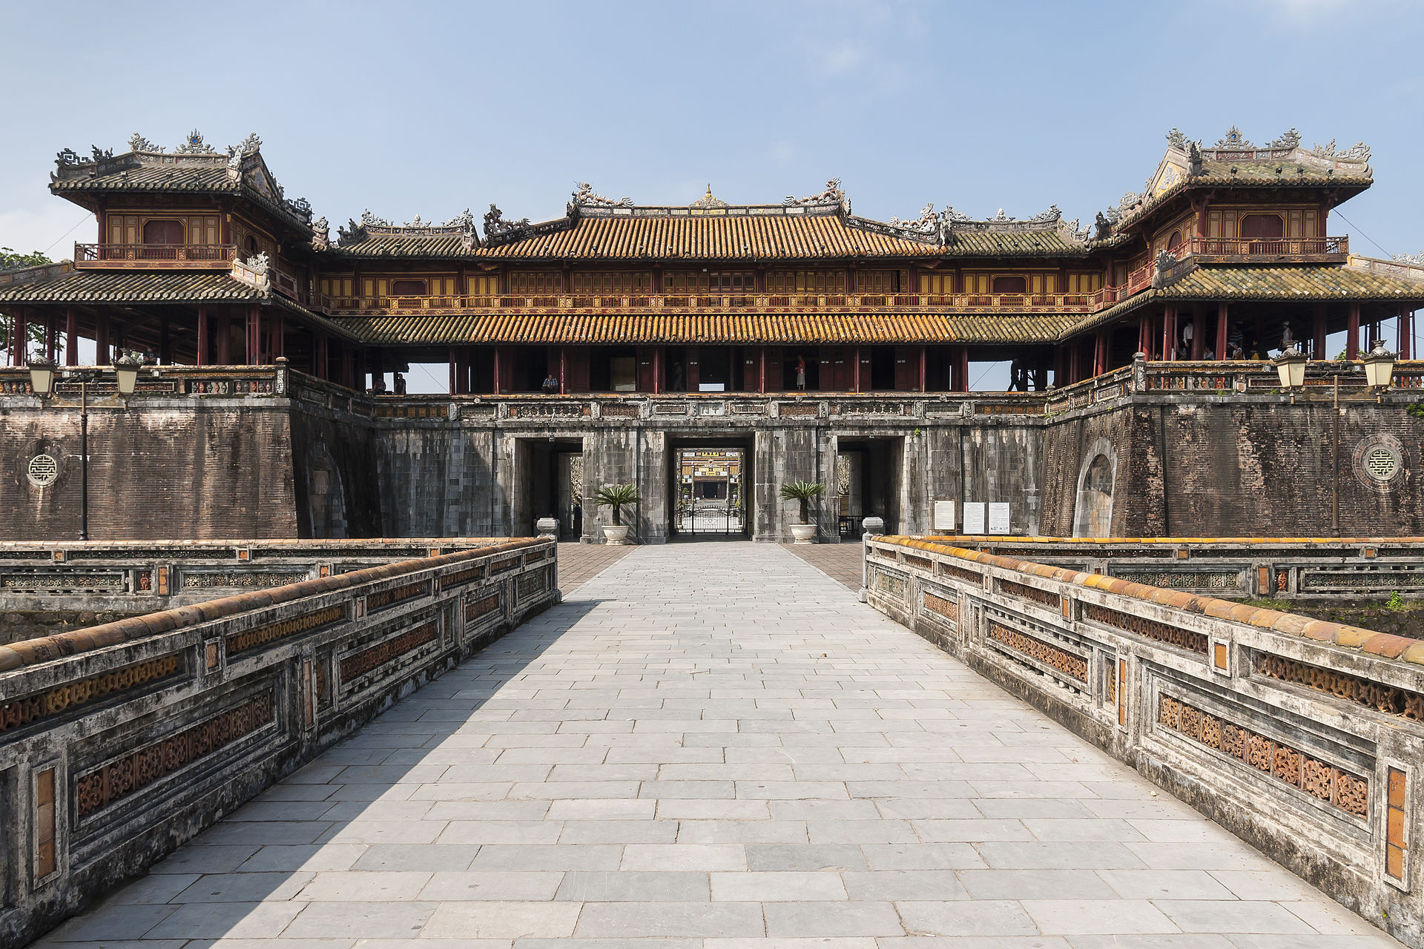

Famously being one of Vietnam’s seven UNESCO World Heritage Sites, the Imperial City of Hue has long been a must-see attraction for tourists visiting a hidden charm of Vietnam. The Imperial City of Hue was actually a walled fortress and palace belonged to the ancient city of Hue which was a capital city of the Nguyen Dynasty for 140 years date back from 1805 until 1945.

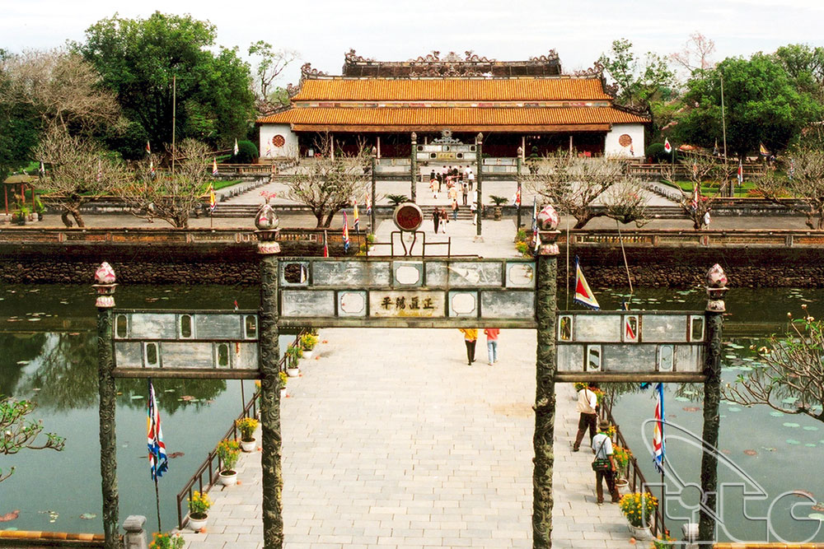

The grandeur architecture was planned to be built in 1803 by Gia Long – an emperor who founded the Nguyen Dynasty. During 27 years from 1805 to 1832, the Imperial City of Hue was finally completed under the reign of Minh Mang, making it the most massive structure being built in the history of modern Vietnam involving thousands of workers, millions cubic meters of rock and huge volume of burden workload. It locates on the northern bank of Huong River, turning South with total land area of 520 ha. The place was made UNESCO Site in 1993 with the remained buildings being actively restored and preserved after the destruction from the Vietnam War.

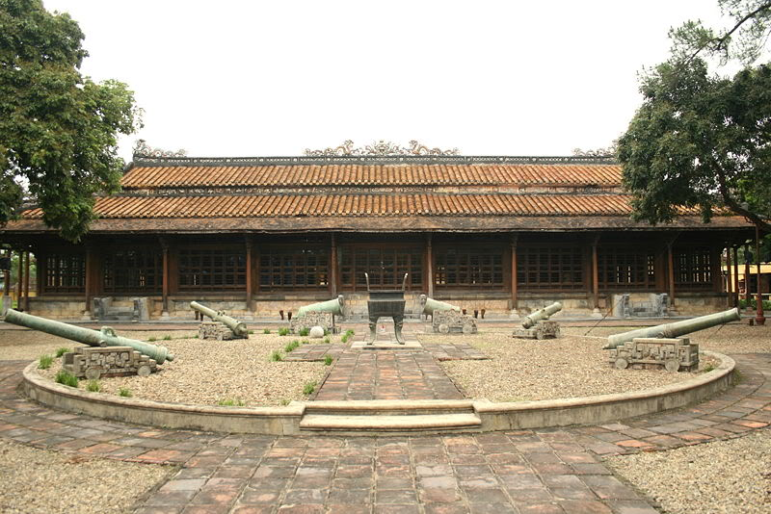

The Imperial City of Hue has a circumference of 10 kilometers with the height of 6.6 meters and 21 meters thick with forts being meanderingly arranged, accompanied by cannons, artilleries and ammunitions. Initially the fortress was built solely by soil, only to be replaced by bricks afterward. Surrounding the city is the complicated canal system served not only as a protection but also as a waterway with nearly seven kilometers.

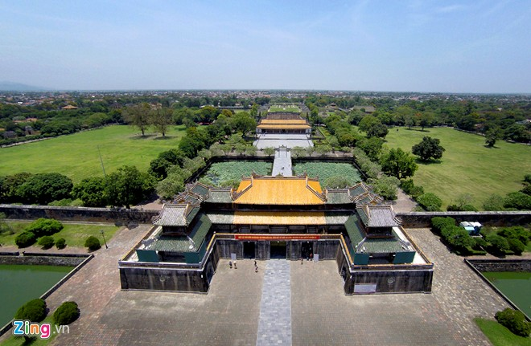

There are total of ten main majestic gates leading to the Imperial City of Hue, which can be divided into two main parts excluding houses and mansions: The Citadel and The Forbidden City. The former served to protect the important palaces inside while the latter was where the emperor and the royal family stayed as well as the court’s workplace. All the typically traditional Eastern architectures including majestic palaces, tombs and museums stand accordantly together to make an utmost amusing attraction right in the heart of Vietnam.

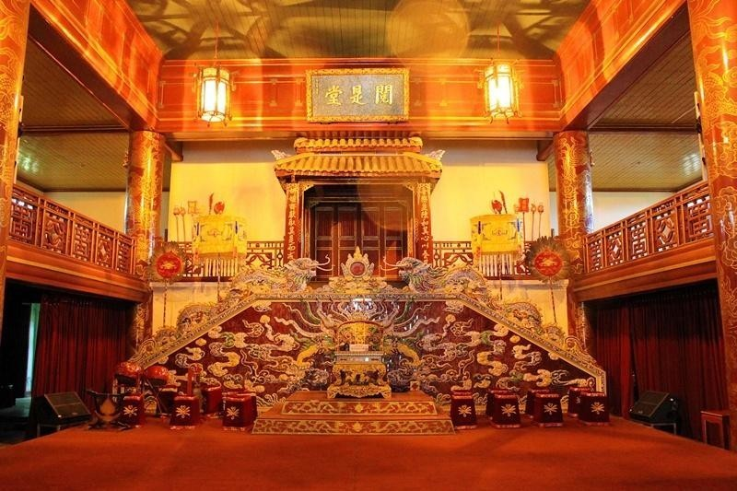

* **Boat Ride on the Song Huong River**

During the autumn, the flower orchards around the river fall into the water, giving it a perfume-like aroma. Hence it is also known as the Perfume River. Enjoy a guided ride on a boat along the river for some scenic views of Hue.

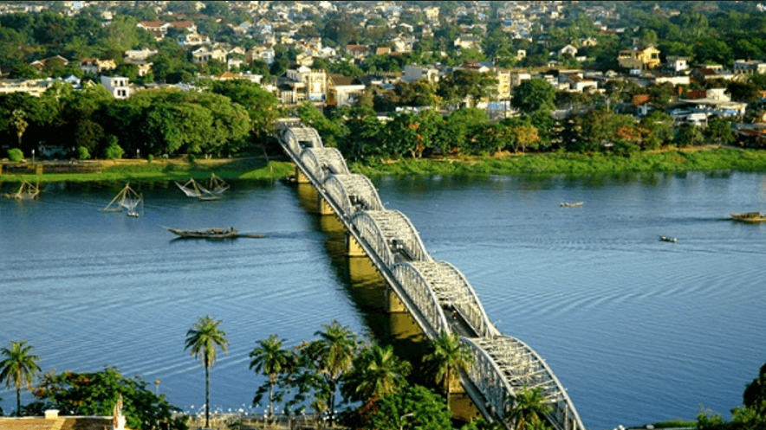

* **Lang Co Beach**

Lang Co is a good stop-by beach with a majestic view if you are ever on your way from Hue to Hoi An. You can enjoy a BBQ seafood lunch at one of the beachside shack cafes. Due to different tides level, it is not recommended that you go for a swim, but the view is scenic.

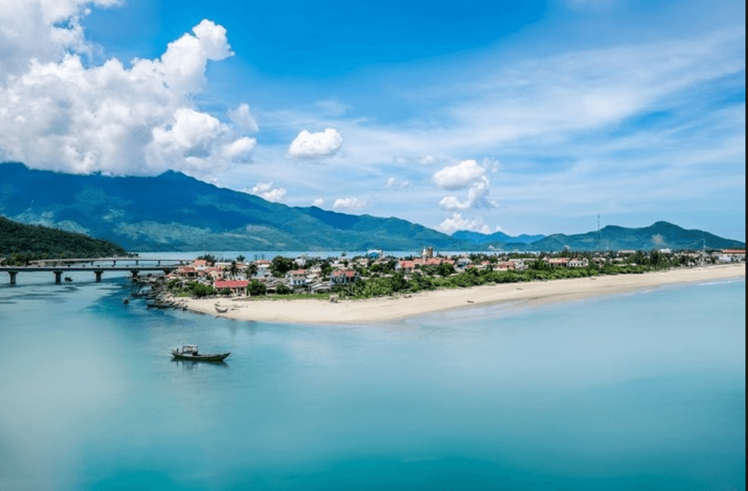

* **Dong Ba Market**

Dong Ba Market is considered the largest marketplace in central Vietnam. This open-air market attracts 5,000 to 7,000 people a day and is bursting with local culture.

This is the best place to go if you want to shop for freshly prepared Vietnamese food. When trying the different foods the market make sure to try some che, or sweet soup, which Hue is well known for.

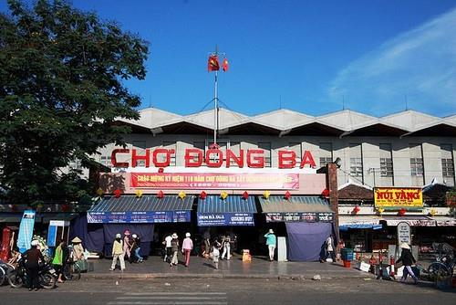

**18:00 PM:** back to hotel to have dinner and relax.

|  |  |
| --- | --- |
|  |  |

|  |  |
| --- | --- |
|  | Relax – Farewell & Goodbye |

**7:30 – 8:30 AM:** Have breakfast at the hotel.

* When ready and as your scheduled bus – train - flight allows, check out of your hotel and we’ll take you to the airport in time for your flight.
* End of Tour.

